Introduction to JavaScript

Date: 12-feb-2019

**Exercise**

1. **Prompt for amount, interest rate and no. of years and calculate simple interest.**

**Index.html**

<!DOCTYPE html>

<html>

<head>

<meta charset="utf-8">

<title>Question 1</title>

</head>

<body>

<h2 style="text-align: center; margin-top: 300px">Question 1</h1>

<script src="app.js" charset="utf-8"></script>

</body>

</html>

**app.js**

(function interest() {

'use strict';

var amount = prompt("Enter Amount: ");

if (amount!=null) {

var interestRate = prompt("Enter Rate of interest: ");

if (interestRate!=null) {

var yearNumber = prompt("Enter Number of years: ");

if(yearNumber!=null){

var SimpleInterest = amount*interestRate*yearNumber;

alert("Simple interest is: "+SimpleInterest);

console.log(SimpleInterest);

}}}

}());

**Output:**

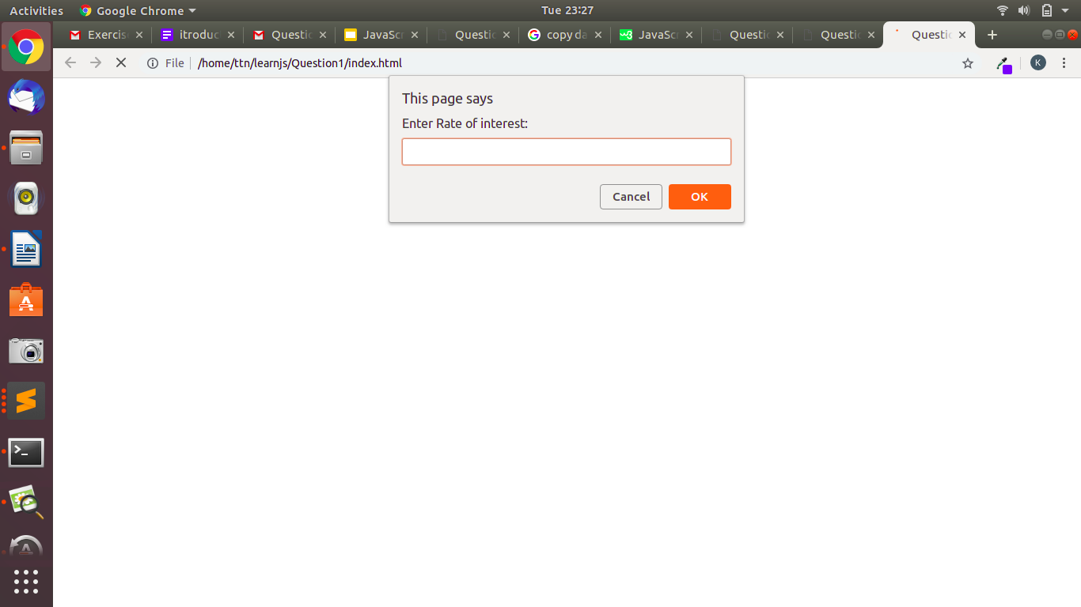

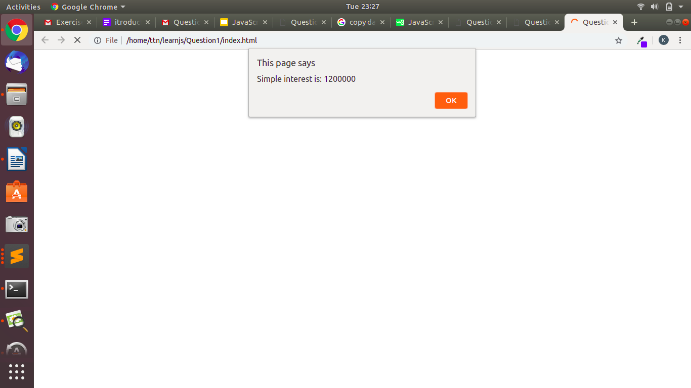

1. **is palindrome string**

<!DOCTYPE html>

<html>

<head>

<meta charset="utf-8">

<title>Question 2</title>

</head>

<body>

<h2 style="text-align: center; margin-top: 300px">Question 2</h1>

<script src="app.js" charset="utf-8"></script>

</body>

</html>

**App.js**

(function palindrome() {

'use strict';

var userInput = prompt("Enter Value for palindrome: ");

var userInputLowerCase = userInput.toLowerCase();

var userArray = userInputLowerCase.split("");

var reverseArray = userArray.reverse("");

var userReverse = reverseArray.join("");

if(userInputLowerCase == userReverse){

alert("This value is palindrome!");

}else{

alert("This value is not palindrome!");

}

}());

**Output:**

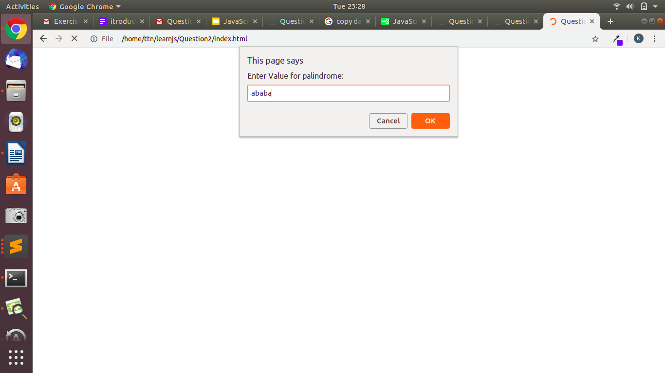



1. **Area of circle**

**index.html**

<!DOCTYPE html>

<html>

<head>

<meta charset="utf-8">

<title>Question 3</title>

</head>

<body>

<h2 style="text-align: center; margin-top: 300px">Question 3</h1>

<script src="app.js" charset="utf-8"></script>

</body>

</html>

**app.js**

(function circleArea (){

var pi = 3.14159;

var radius = prompt("Enter the value of radius: ");

var areaOfCircle = (pi*radius*radius);

alert("Area of Circle is : "+ areaOfCircle);

}());

**Output:**

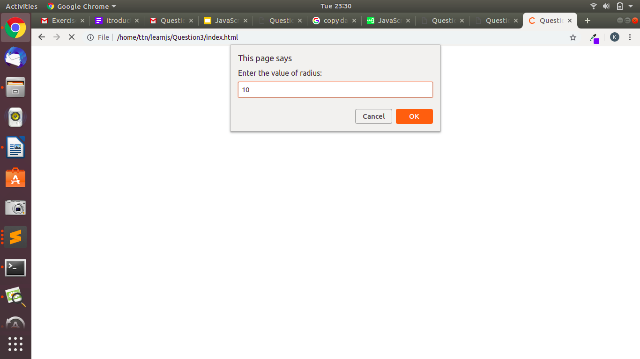

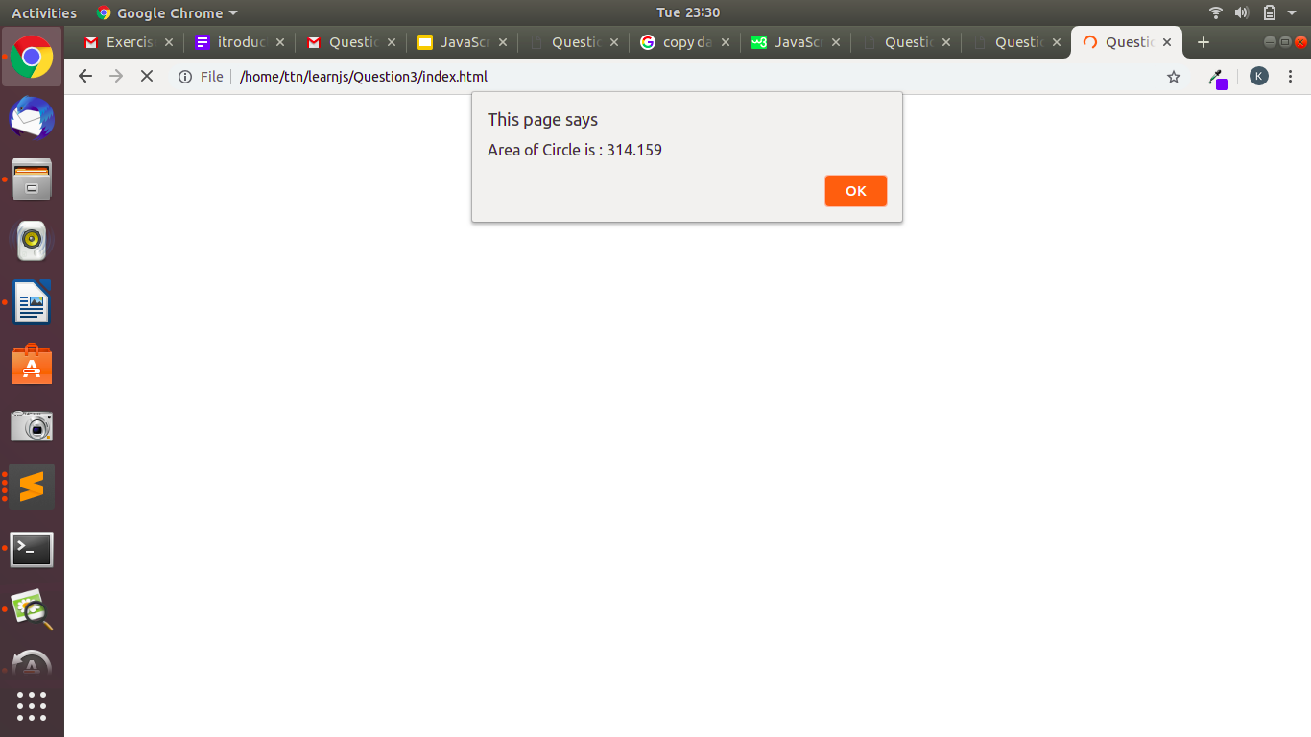

1. **Copy information of one object to another and log it to console.**

**index.html**

<!DOCTYPE html>

<html>

<head>

<meta charset="utf-8">

<title>Question 4</title>

</head>

<body>

<h2 style="text-align: center; margin-top: 300px">Question 4</h1>

<script src="app.js" charset="utf-8"></script>

</body>

</html>

**app.js**

(

function copyObjectData(){

var myDetails = {

name: prompt("Enter your name:"),

age: prompt("Enter your age:"),

location: prompt("Enter your location:"),

college: prompt("Enter your college:"),

course: prompt("Enter your course:"),

}

console.log("Original object details: ", myDetails);

var copyObject = Object.assign({},myDetails);

console.log("New Object Value: ",copyObject);

}());

**Output:**

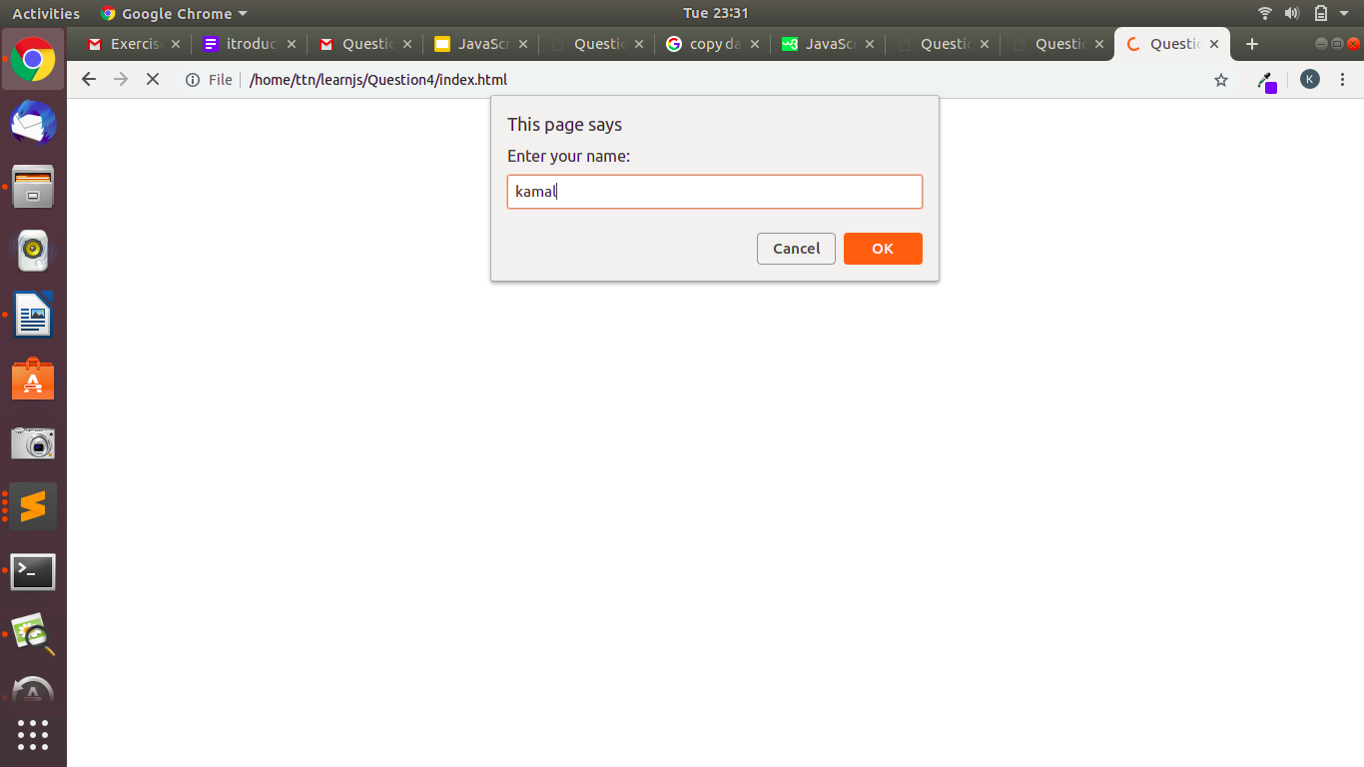

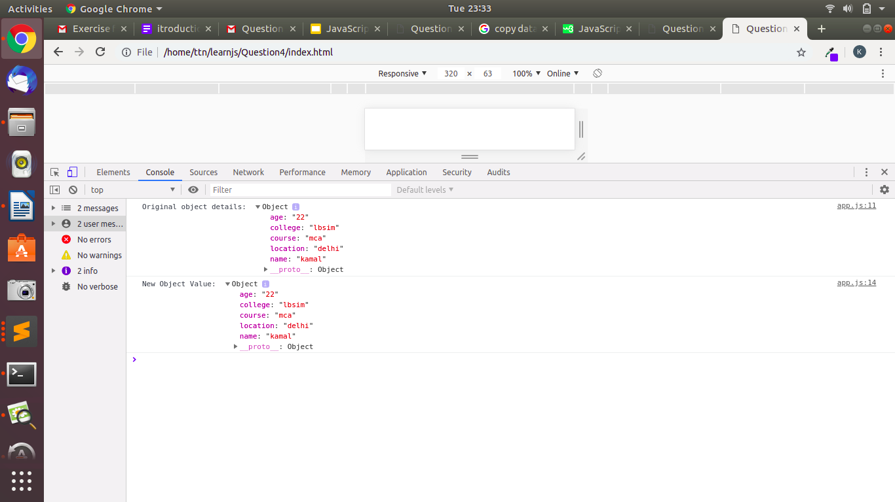

1. **create a list of objects of Employee with info as follow :**
   * **Name, age, salary ,DOB**
   * **filter all employees with salary greater than 5000**
   * **group employee on the basis of their age**
   * **fetch employees with salary less than 1000 and age greater than 20. Then give them an increment 5 times their salary.**

**index.html**

<!DOCTYPE html>

<html>

<head>

<meta charset="utf-8">

<title>Question 5</title>

</head>

<body>

<h2 style="text-align: center; margin-top: 300px">Question 5</h1>

<script src="app.js" charset="utf-8"></script>

</body>

</html>

**app.js**

(function emoloyeeDetail()

{

var employee = [

{ Name: 'Kamal', Age: 22, Salary: 7000, DOB: '27/11/1996' },

{ Name: 'Joyesh', Age: 23, Salary: 6000, DOB: '23/04/1995' },

{ Name: 'Rohit', Age: 27, Salary: 800, DOB: '27/11/1993' },

{ Name: 'Mohit', Age: 20, Salary: 950, DOB: '27/11/1993' },

{ Name: 'Sonu', Age: 18, Salary: 1000, DOB: '27/11/1993' },

];

console.log("1.");

console.log("List of all employees= ",employee);

console.log("2.");

for(var i=0;i < employee.length;i++)

{

if(employee[i].Salary > 5000)

console.log("Employees whose salary is greater then 5000 = ",employee[i]);

}

console.log("3.");

for(var i=0;i < employee.length;i++)

{

if(employee[i].Age < 20)

console.log("Employees whose age is less then 20 = ",employee[i]);

else if(employee[i].Age >= 20 && employee[i].Age < 25)

console.log("Employees whose age is greater then or equal to 20 and less then 25 = ",employee[i]);

else

console.log("Employees whose age is greater then 25 = ",employee[i]);

}

console.log("4.");

for(var i=0;i < employee.length;i++)

{

if(employee[i].Salary < 1000 && employee[i].Age > 20)

{

var inc = employee[i].Salary * 5;

console.log("Salary of ",employee[i].Name," after increment= ",inc);

}

}

}

());

**Output:**

